Project Design Phase-II
Data Flow Diagram & User Stories

Date | 03 October 2026
Team ID | SWTID-2026-2035
Project Name | Implement Client Script & UI Policy (Incident)
Maximum Marks | 4 Marks

Data Flow Diagrams:
A Data Flow Diagram (DFD) is a traditional visual representation of the information flows within a system. A neat and clear DFD can depict the right amount of the system requirement graphically. It shows how data enters and leaves the system, what changes the information, and where data is stored.
ServiceNow Incident DFD
Project-specific (workflow)
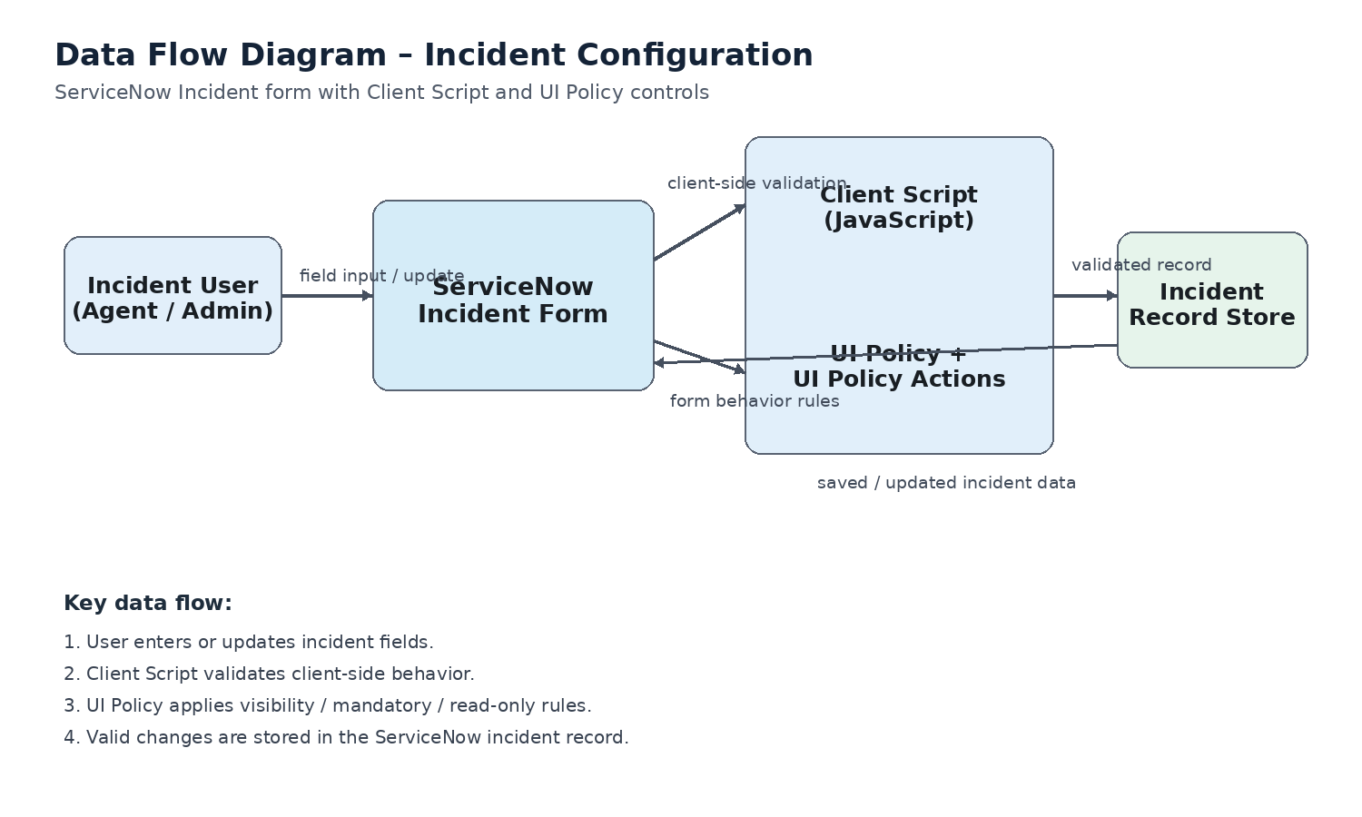
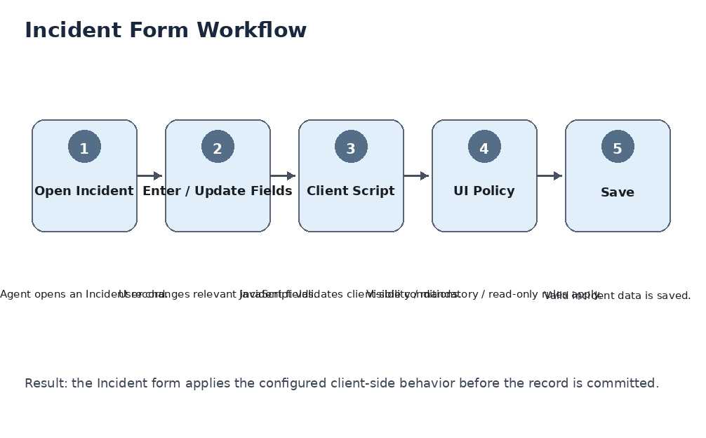

User Stories
Use the below template to list all the user stories for the product.
User Type | Functional Requirement (Epic) | User Story Number | User Story / Task | Acceptance criteria | Priority | Release
ServiceNow Agent | Incident Form Validation | USN-1 | As an incident agent, I can enter and update Incident fields with the configured client-side validation. | Configured validation executes on the Incident form and prevents invalid input. | High | Milestone-1
 | Client Script | USN-2 | As an incident agent, I can receive immediate feedback when an Incident field value does not meet the configured rule. | The client-side rule displays the expected validation behavior without requiring a server round trip. | High | Milestone-1
 | UI Policy | USN-3 | As an incident agent, I can see Incident fields become visible, mandatory, or read-only according to the configured UI Policy condition. | The relevant field state changes automatically when the condition is met. | High | Milestone-2
 | Form Behavior | USN-4 | As an incident agent, I can save an Incident after the configured Client Script and UI Policy rules are satisfied. | The Incident saves successfully when all configured conditions are satisfied. | High | Milestone-2
ServiceNow Administrator | Configuration | USN-5 | As an administrator, I can configure the Client Script for the Incident form. | The Client Script is active and executes on the intended Incident form event. | High | Milestone-1
 | Configuration | USN-6 | As an administrator, I can configure the UI Policy and its UI Policy Actions for Incident fields. | The UI Policy applies the intended field behavior when its condition is true. | High | Milestone-2
 | Testing | USN-7 | As an administrator, I can test the configured Client Script and UI Policy using Incident records. | The expected validation and field-state behavior can be demonstrated and captured as evidence. | Medium | Milestone-2
ServiceNow User | Incident Update | USN-8 | As a ServiceNow user, I can update an Incident while the configured form rules remain consistent. | The same configured behavior is applied during Incident updates. | Medium | Milestone-2
Administrator

